Download java jdk from below link  
https://www.oracle.com/bd/java/technologies/downloads/  
  
copy the file path such as:  
C:\Program Files\Java\jdk-23\bin  
  
then go to edit the system environment variables and select environment variables  
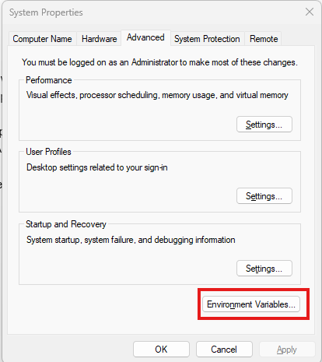  
  
then click on new button under system variables  
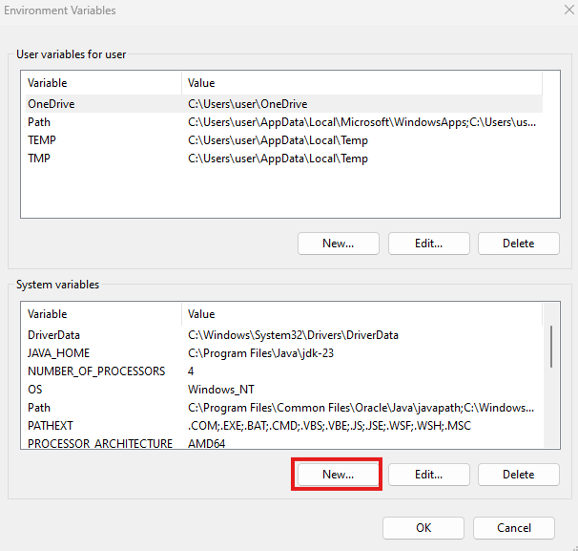  
save the variable value without /bin   
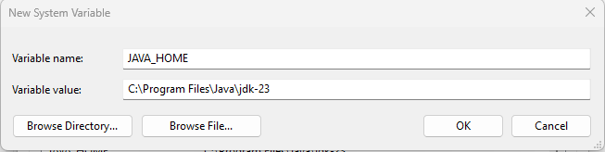  
  
then press OK.  
  
then double click on the path.

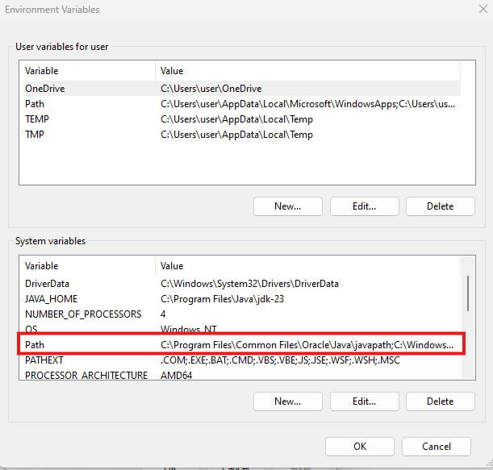  
  
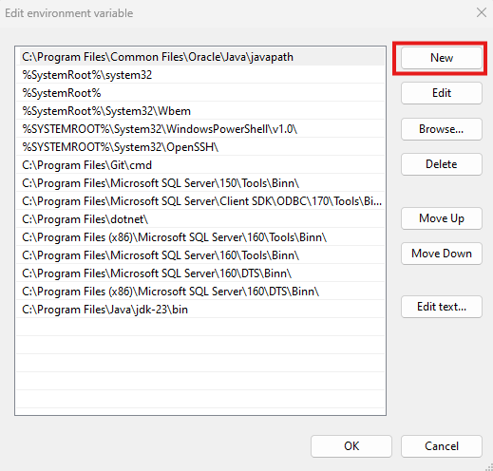  
  
click new and paste the path here :  
C:\Program Files\Java\jdk-23\bin  
 and save it

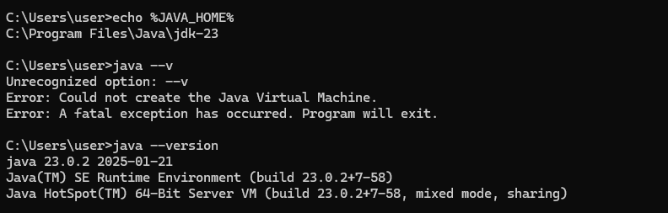  
  
download intellij IDEA from below link  
https://www.jetbrains.com/idea/download/?section=windows